A Mobile Go-n-Grasp Application for School Canteens
REPORT
Soukaina Nait Hmid 3035077753
Ofembe Eneufei Emmanuel 2009539315

Contents
1. INTRODUCTION 3
1.1 Project objective 3
1.2 Economical context 3
1.3 Operational context 3
2. PRODUCT REQUIREMENTS 3
2.1 Product requirements. 3
Principal function 3
Secondary function 3
Constraints 3
List of functions 3
2.2 Non-functional requirements 4
Security 4
Response time 4
Maintainability 4
Portability 4
2.3 Product development requirements 4
2.3.1 Deadline 4
2.3.2 Cost 4
2.3.3 Realization constraints 4
2.3.4 Planning 5
3.THE PRODUCT 5
3.1 Used tools 6
3.2 User interface(UI) description 6
Client Side 6
Server side 6
3.3 Database structure 7
Assumptions 8
Bugs 8
Possible improvements 8

1. INTRODUCTION

1.1 Project objective
To facilitate ordering of food at canteens at the University Of Hong Kong by reducing queuing.

1.2 Economical context
Reducing waiting time at canteens and creating a system of asynchronously ordering food is time efficient in two major aspects - reducing time needed to collect customers' requests and saving the customer time that could be spend on other productive activities.

1.3 Operational context
The system allows the administrator at the canteen to update the menu which can be accessed by customers through the web for viewing and placing orders in advance for estimating the appropriate time to the canteen without the need to wait in the queue.

2. PRODUCT REQUIREMENTS

2.1 Product requirements.

Principal function
Accessing the canteen' menu and placing orders through the internet.

Secondary function
Allowing the canteen administrators to be able to update the menu with items and availability times.

Constraints
The application cannot be completely efficient because not all customers will use the application for various reasons such as the lack of internet access. For the sake of simplicity and modeling, the situation is assumed to be the ideal case where all customers use the application for placing orders.

List of functions
Function | Permission | Description
Log in | Client/Admin | The client or admin is required to log in before obtaining access to the database.
Order | Client | The client can place an order
Add item | Admin | Only admin can add items to the menu
Delete item | Admin | Admin can delete items
Modify | Admin | Admin can modify items

2.2 Non-functional requirements

Security
Every user has a username and password with the university's computer centre. Authentication in this database is required for the user each time before placing the order.

Response time
Response time can vary depending on the bandwidth and traffic in the network and also on the number of simultaneous requests being made to the server. Under normal circumstances, response time should be more than a few seconds. The data passed between the client and server each time should be no more than the size of a simple database query from the client and a response with the items on the menu.

Maintainability
The contents of the database(menu items) are managed by the canteen administrator

Portability
The server side of the application runs on a web server. This means that the application can be easily moved from one system to another by simply copying its contents. Since the database is also running on a different server, each piece of the program can run on an independent system with an internet connection.

2.3 Product development requirements

2.3.1 Deadline
Gantt chart

2.3.2 Cost
 | Data | Hardware
User | Internet | Computer
Admin | Internet | Mobile device/computer

The administrator costs are those from the internet data and web hosting. The client's costs are internet data costs and device hardware costs.

2.3.3 Realization constraints
The main constraint is cost. Either the cost of internet data or hardware. The user or administrator might not have a suitable hardware device or internet connection. This implies that the situation can arise where all customers to not have an internet connection.

2.3.4 Planning
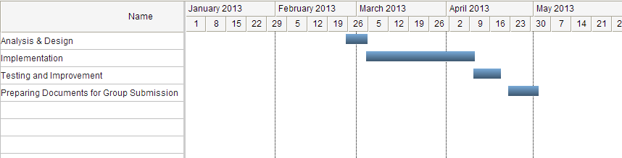

3.THE PRODUCT
The project contains a server and a client side. The server side uses web service and phpMyAdmin database.
The web pages under the folder 'yumyum' are:
authenticate.php for authenticating the administrator in order to redirect to yumhome.php.
yumhome.php: is the interface from which the admin can add food to the menu, modify and
see the current situation of the stock.
The following details are required for adding food:
-the name
-the type
-the time of availability (from/to)
-the frequency of production
-the price
The food is then added to database under phpMyAdmin in the food table with an auto-incremented index. At the same time, every single item of a product produced in a exact time between "from" and "to" is stored in the table "foodItem".
This will help later for estimating the time to take for the client.
Client Side uses Android SDK 4.2.2.
The application contains three activities:
In each activity, we need to set connections to the server to receive/send data.
The connection to the server cannot be made in the main thread. Thus, we use a subclass extending AsyncTask to set the connection in the background.
"MainActivity" for authenticating.
"DisplayMessageActivity" looks for the food that is still in stock and displays the name and price of each in a listView with a checkbox in each row and then, sends the id of the checked food item to the next activity.
"Reservation" looks for the earlier items of the order so as to estimate the time of availability
and deletes this item from the "fooditem" table.

3.1 Used tools
HTTP Server(Apache) | The Apache web server is used for the back end programs.
SQL Database management(PHPMyAdmin) | The SQL database is used in the project and the PHPMyAdmin web tool is used for database management.
PHP/HTML/CSS | The programming languages used for the web applications(primarily for the back end) is PHP. HTML and CSS are used to provide an interface for the user to interact with the database.
Android SDK with Eclipse IDE | The Android SDK is the tool of choice for development of the mobile application that runs on the Android operating system.

3.2 User interface(UI) description

Client Side
The UI at the client side will contain a dialog for the user to log in and another for viewing the menu.
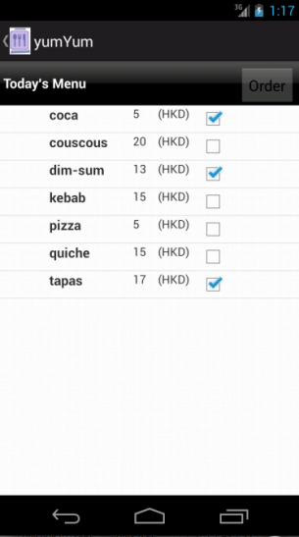

Server side
The server side will contain a web page to allow the canteen administrator to be able to modify the items on the menu.
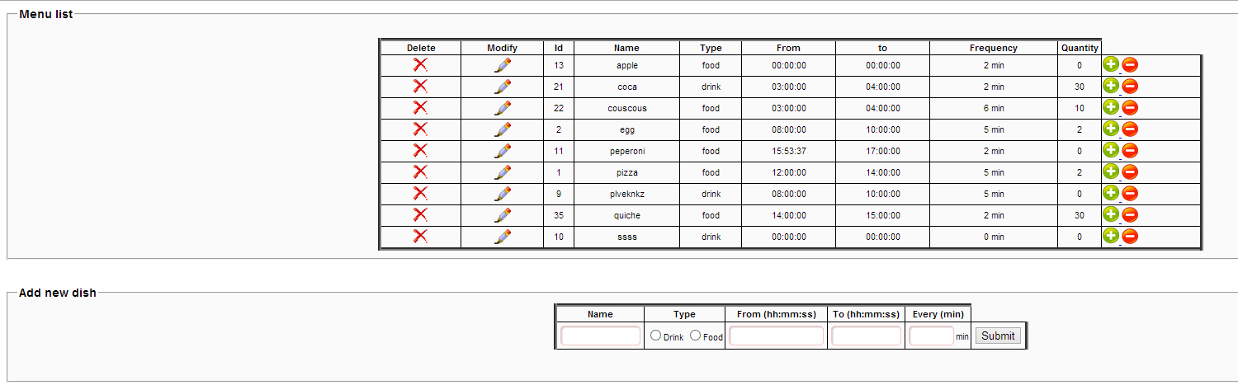

3.3 Database structure
The database has three tables; food, fooditem and login.
Table | Description
food | List of all food items on the menu
fooditem | Each food item in each food category
login | Username and password table

food table
Field | Description
id int(30) | Unique id if the food item
name varchar(30) | The unique name of the food item
type enum('food', 'drink') | Whether drink or food
from time | Time of start of availability
to time time | Time of end of availability
Frequency int(11) | Frequency of production
Price int(11) | The price of the food item

fooditem table
Field | Descriptions
id int(30) | Unique id of item
time time
food_id int(30) foreign key food.id | The id of the corresponding item on the food table

login table
Field | Description
user varchar(8) | The username of the user
pass varchar(8) | The password of the user
Status enum('user','admin') | Determines if logging in as user or admin

Assumptions
It is assumed that the every customer uses the application for ordering food and that the administrator posts items on the menu on the same day they will be available.
Bugs
-Line 217 in DisplayMessageActivity in showAlertView function where we pass the id of the food as a parameter to the activity Reservation.
bundle.putString("id", id);
Intent intent = new Intent(a, Reservation.class);
intent.putExtras(bundle);
finish();
a.startActivityForResult(intent, 0);
When the id is superior to 9 the return value of the time is null! Otherwise it works normally. Perhaps we can only pass one character with bundle.
-also it did not work when I tried to send an array of ids (if multiple choice). So this solution only works when a single item is checked.
Possible improvements
-add in the UI the possibility to subscribe.
-add controls to the text the fields.
-use sessions for administrator interface.
-rework the transitions between activities.

